Course Two Week Four: Pivot Activity Instructions

Open the file contained within the folder name shown above.
Create a pivot table of the property portfolio to show:
- The asking price as the value field;
- The type of property in the rows;
- The location in the columns;
- The remaining fields in the filter area.
Change the filters and aggregate functions to show a count of properties that have:
- 3 bedrooms;
- A medium garden; and
- 2 bathrooms.
Your pivot table should look something like this:
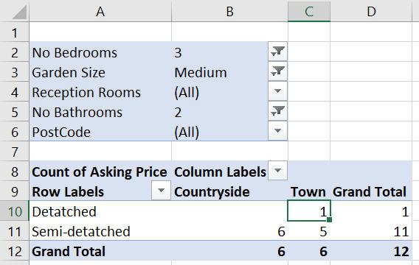
Use the filters at the top to only show the data you are interested in.
There is only one property that is detached and location town - use drill down to show this:
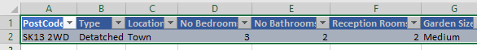
Double-click on cell C10 to see the property details.
Change your pivot table so that it now shows the average asking price of houses with:
- The postcode of the property in the rows;
- The type of property in the columns; and
- The remaining fields in the filter area.

Double-click on any property price to see the full details.
Use Save As... to save the file in your own new Excel work folder.

